**Date:**

**TASK4: Apriori**

**Aim:** Program to find the association rules using Apriori algorithm for the dataset.

**Data set:** Groceries Data set

**Source:** Github Repository

**Association rules:**

Association is a data mining function that discovers the probability of the co-occurrence of items in a collection. The relationships between co-occuring items are expressed as association rules. Association rules are often used to analyse sales transactions.

Association rules are if/then statements that help uncover relationships between seemingly unrelated data in a relational database or other information repository.

**Itemset:**A set of one or more items.

Eg:{Milk, Bread diaper}

**K-Itemset:**An itemset that contains k items.

**Support count(**σ): Frequency of occurrence of an itemset.

Eg: σ ({Milk, Bread, Diaper}) =2.

**Support:** Fraction of transactions that contain an itemset.

E.g.({Milk,Bread,Diaper})=2/5

**Frequent Itemset:**An itemset whose support is greater than or equal to aminsup threshold.

**Association Rule:**An implication expression of the form x->y,where x and y are

itemsets.

Example:{Milk,Diaper}->{Beer}

**Rule Evaluation Metrics:**

-**Support(s):**Fraction of transactions that contain both x and y

**-confidence(c):**Measures how often items in Y appear in transactions thatcontain x

**Apriori principle**:if an itemset is frequent,then all of its subsets must also befrequent.

Apriori principle holds due to the following property of the support measure:

For all x,y:(xcy)=>s(x)>s(y)

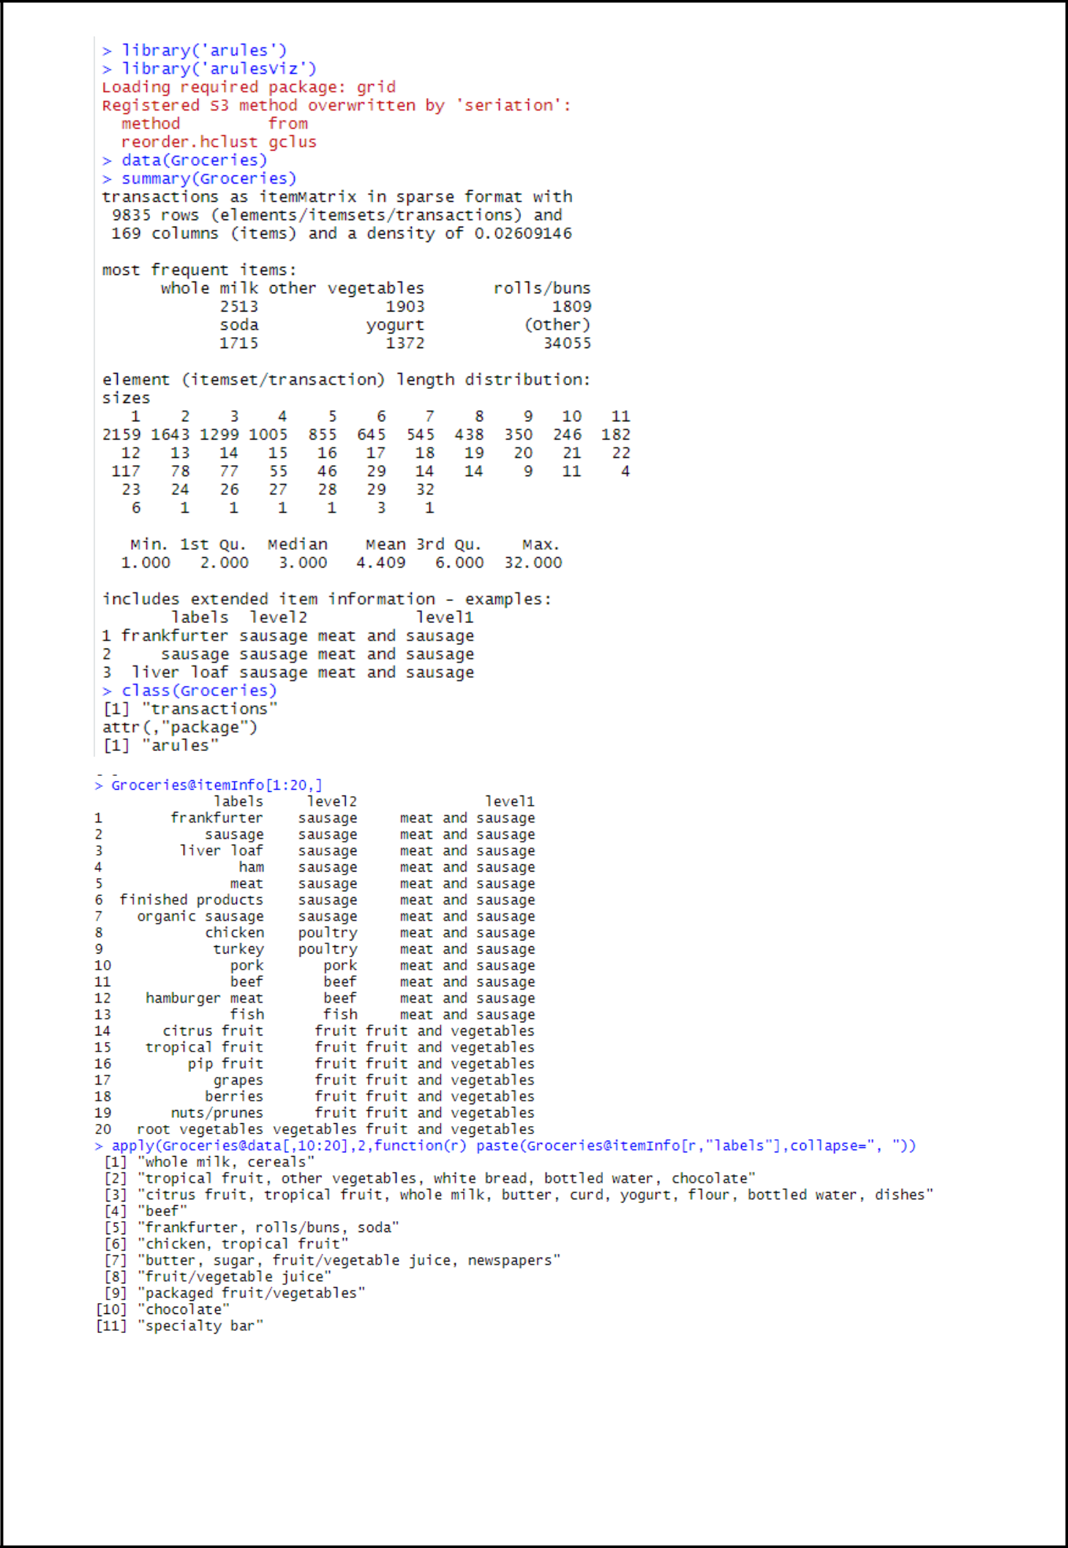

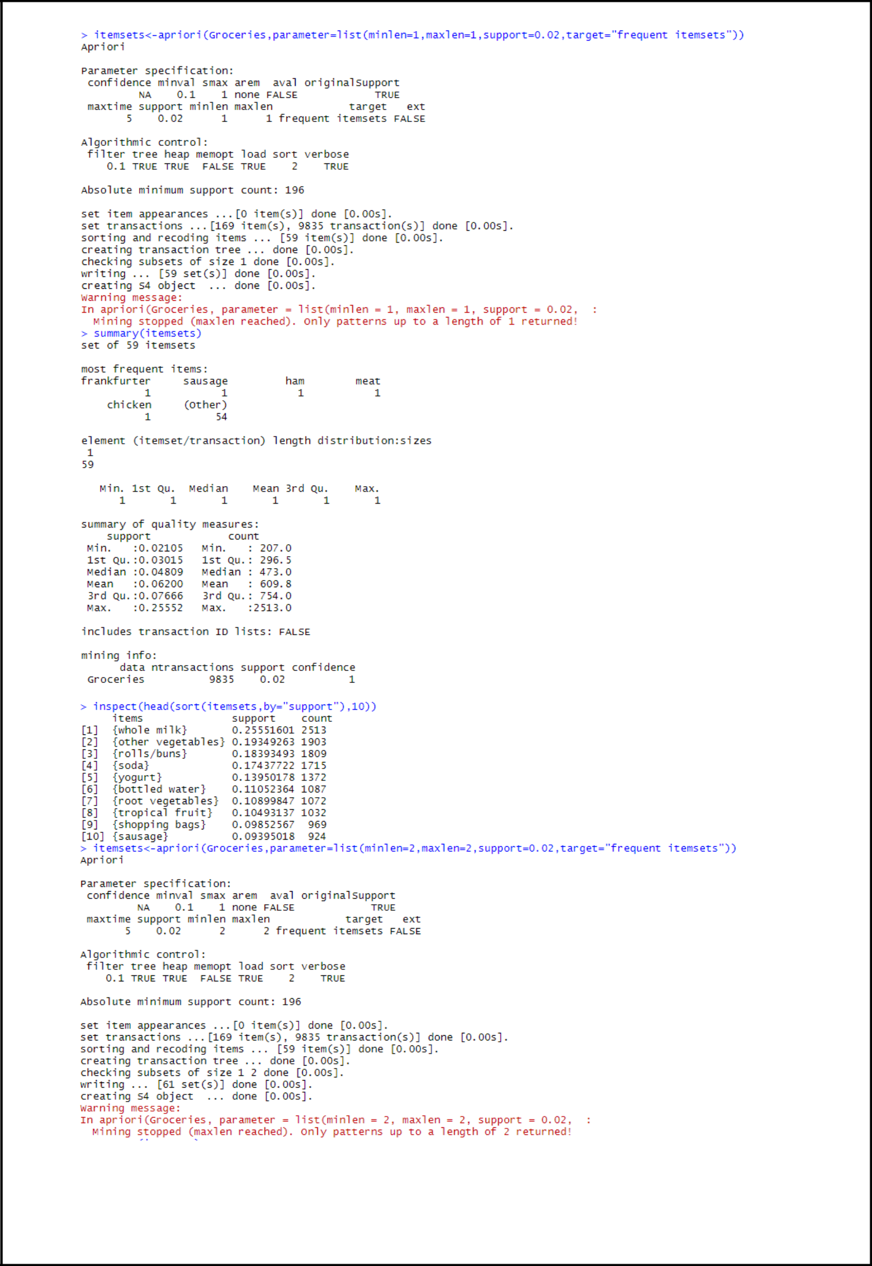

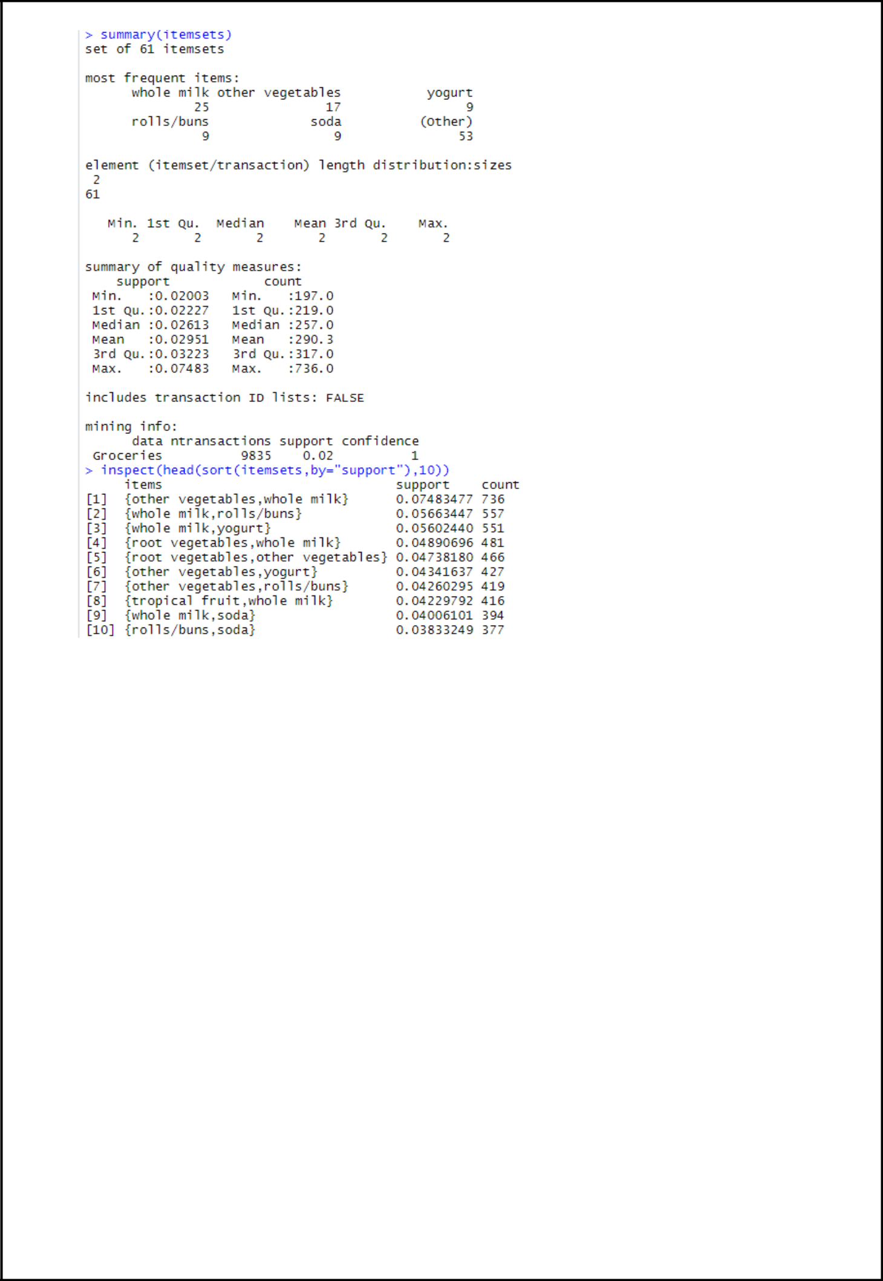

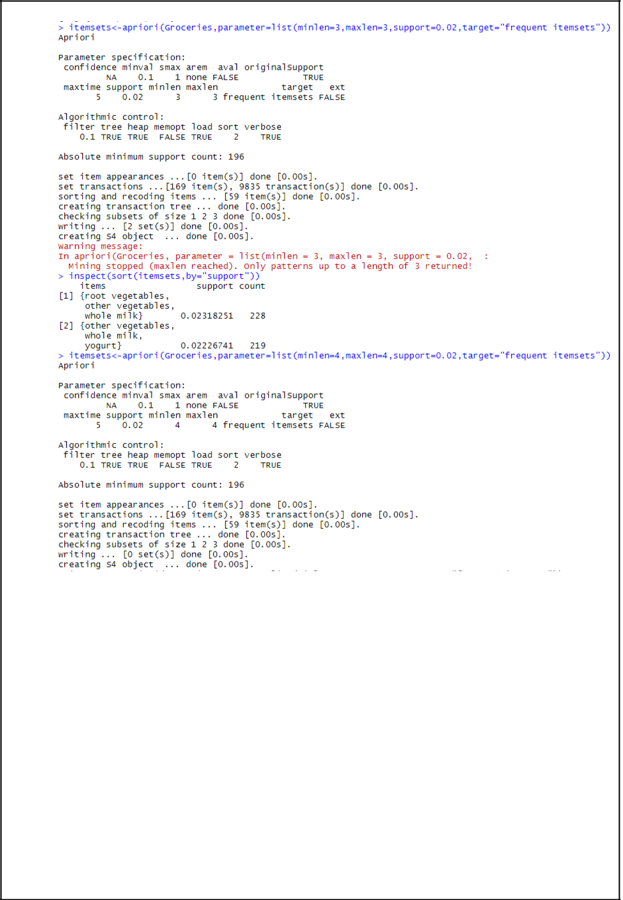

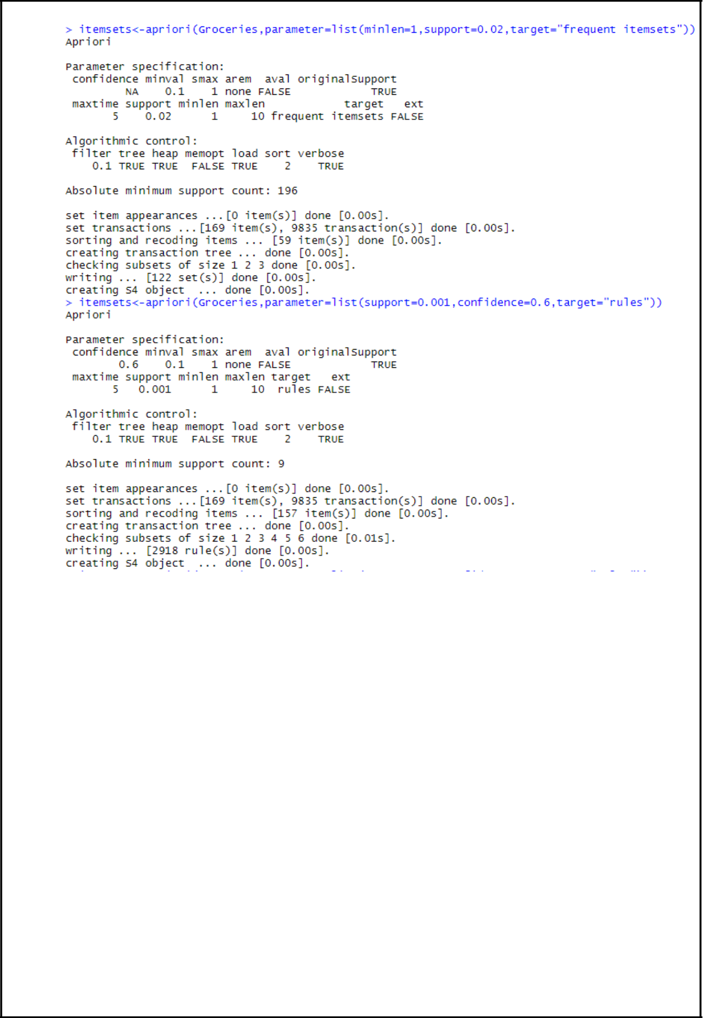

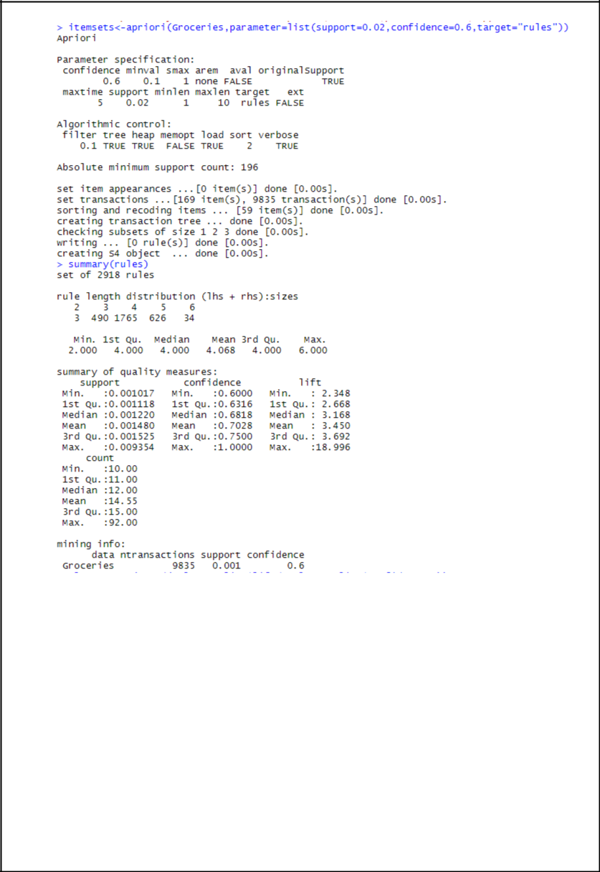

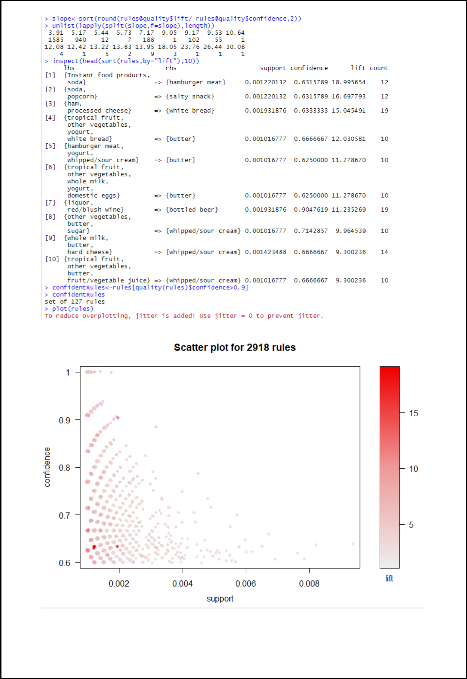

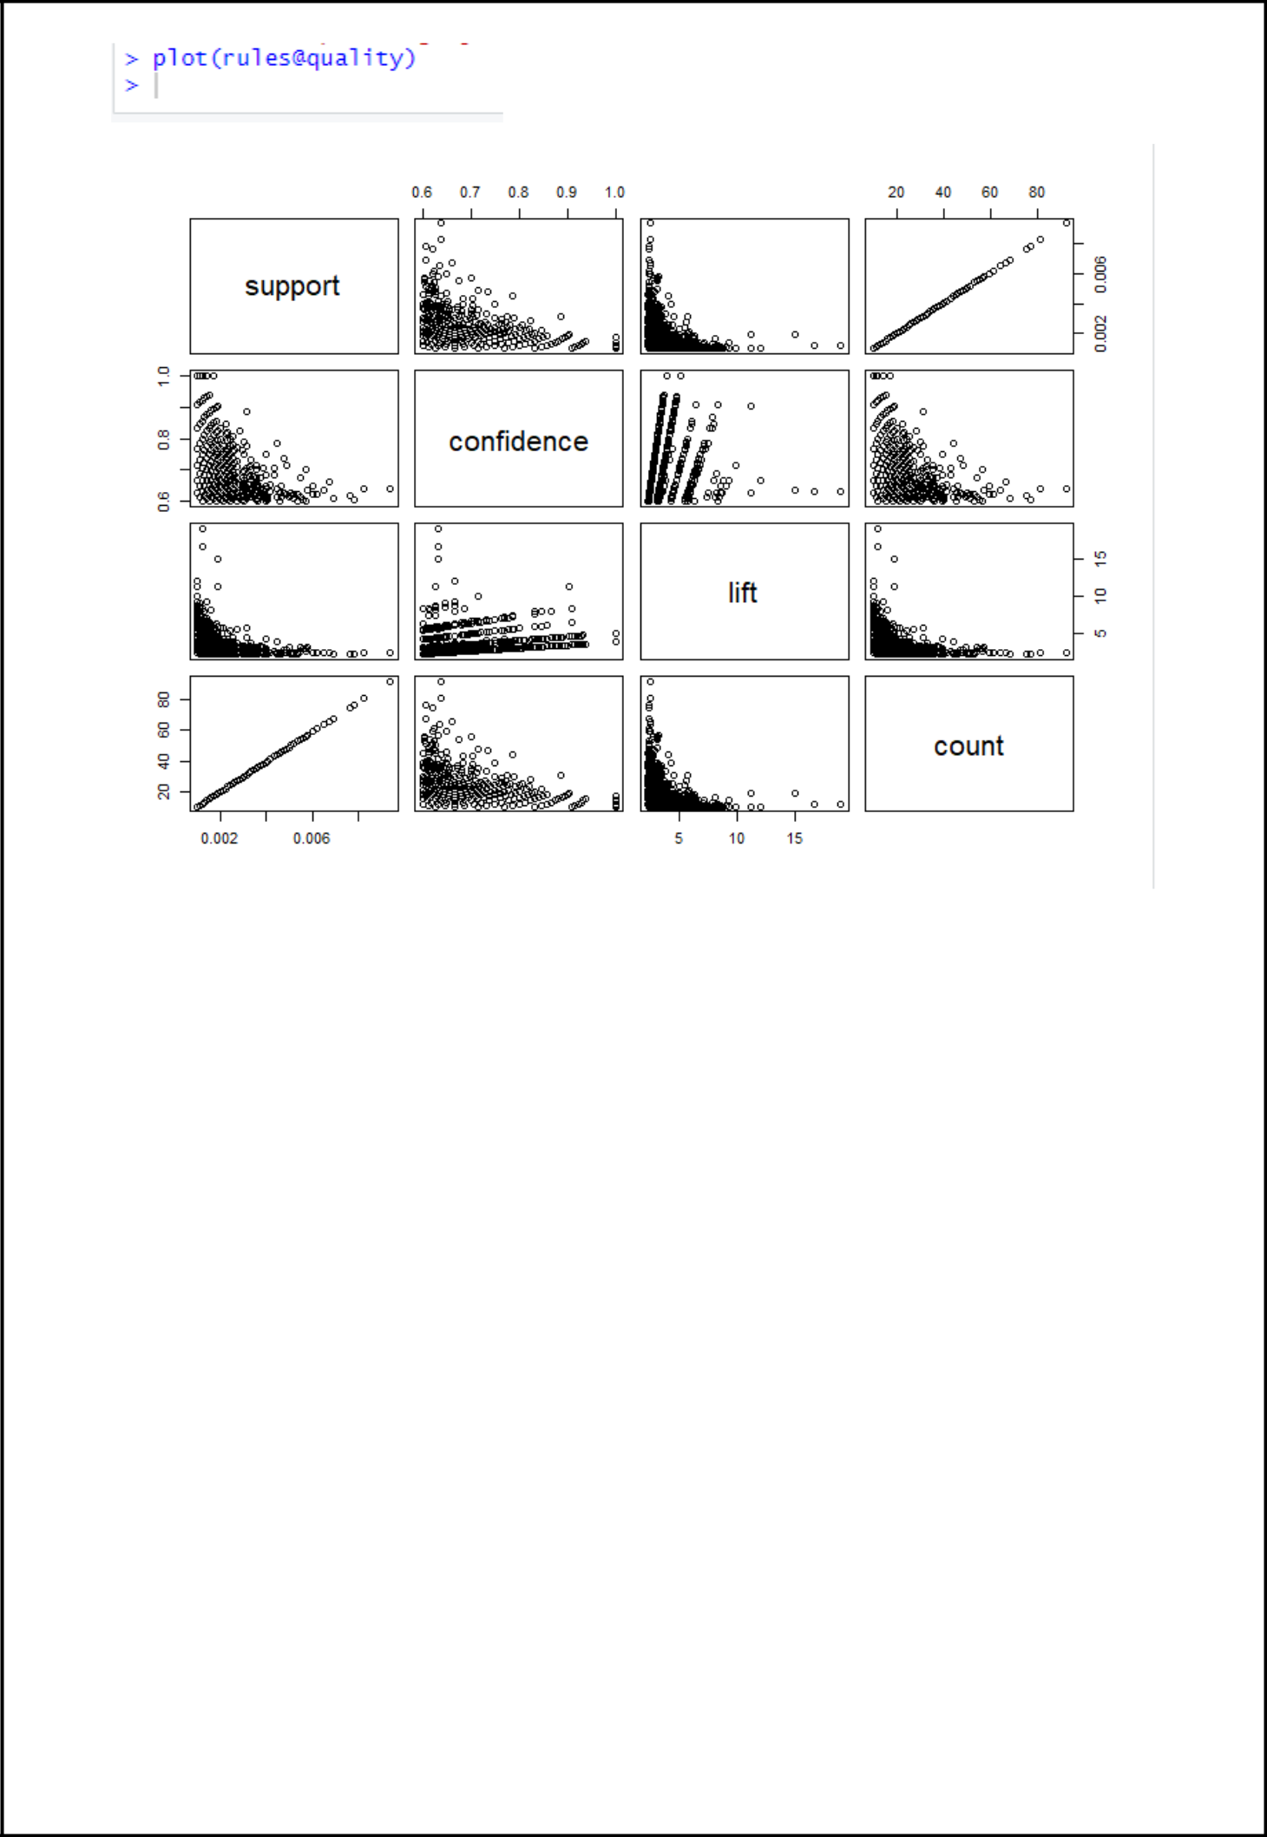

**RESULT:** The above method Apriori is implemented successfully.